**Optimizing User, Group, and Role Management with Access Control and Workflows**

**Team ID : NM2025TMID18225**

|  |  |  |
| --- | --- | --- |
| Name | NM ID | Position |
| MANOJ KUMAR C | **C8DC5FBFD7D6703AA7142CEE1EA8B6FC** | **Leaded** |
| GABRIEL MILTON G | **5CBA39C0FB639A2822746EC7B6F0B3DA** | **Member** |
| GOKUL T | **3C4C605D7881033AB4B47DF21B288738** | **Member** |
| KUMARAN S | **AFC2ED17244495D815840FF80DB59DA5** | **Member** |
| SRIDHAR C | **AE93B8E8AB251309D2F400217727ED39** | **Member** |

TABLE OF CONTENTS

|  |  |  |
| --- | --- | --- |
| **S.No** | **Title** | **Page No** |
| **1.** | **About the Project** | **1** |
| **2.** | **Creating Users** | **2** |
| **3.** | **Creating Groups** | **4** |
| **4.** | **Creating Roles** | **5** |
| **5.** | **Creating Tables** | **6** |
| **6.** | **Assign Users to Groups** | **8** |
| **7.** | **Assign Roles to Users** | **9** |
| **8.** | **Assign table access to the Application** | **11** |
| **9.** | **Create ACL** | **12** |
| **10.** | **Creating Flow Designer** | **14** |
| **11.** | **Conclusion** | **18** |

# Problem Statement:

In a small project management team consisting of a Project Manager (Alice) and a Team Member (Bob), there is a need to efficiently manage project tasks and ensure accountability throughout the project lifecycle. The current system lacks clear role definitions, access controls, and a structured workflow, leading to confusion regarding task assignments and progress tracking.

# Objective:

The project aims to design and implement a streamlined framework for managing users, groups, and roles in an enterprise system, with robust access control policies and automated workflows. This ensures secure, efficient, and role-based access to resources, thereby improving system governance, reducing administrative overhead, and enhancing compliance with organizational and regulatory requirements.

# Skills:

* **Technical Skills**: User, group, and role management, access control (RBAC), workflow automation, IAM tools (Service Now/Active Directory), scripting for automation, audit & compliance management.
* **Soft Skills:** Problem-solving, analytical thinking, project management, teamwork, documentation, and attention to details.

# TASKINITIATION

**Milestone 1 : Users Activity1:CreateUsers**

* 1. Open service now.
  2. Click on All>> search for users.
  3. Select Users under system security.
  4. Click on new.
  5. Fill the following details to create a new user.
  6. Click on submit.

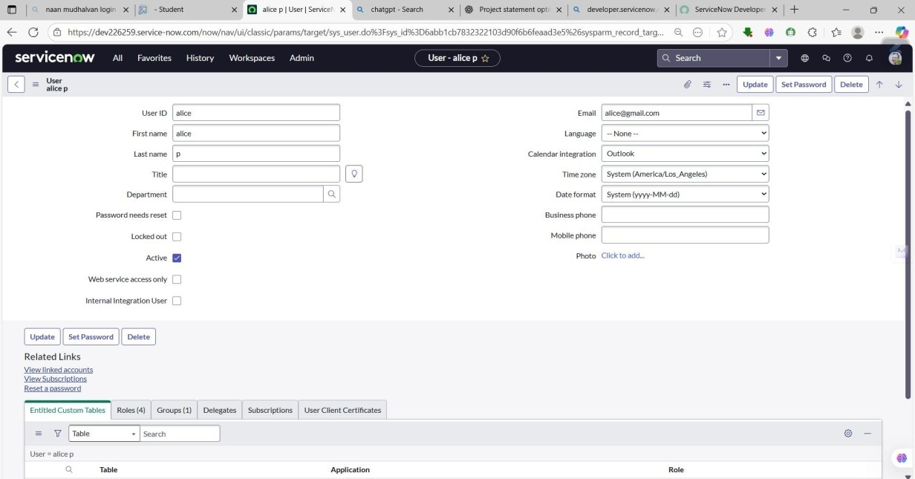

# Create one more user:

* 1. Create an other user with the following details.
  2. Click on submit.

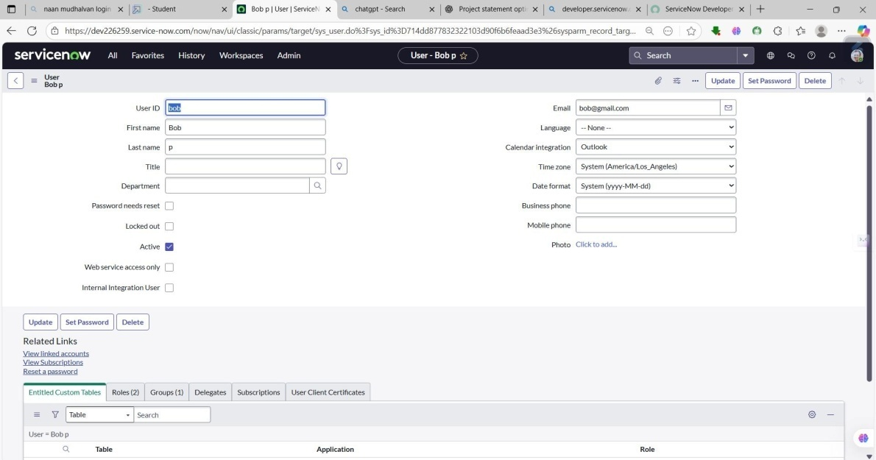

# Milestone 2 : Groups Activity 1:Create Groups

1. Open service now.
2. Click on All>> search for groups.
3. Select groups under system security.
4. Click on new.
5. Fill the following details to create a new group.
6. Click on submit **Project Title.**

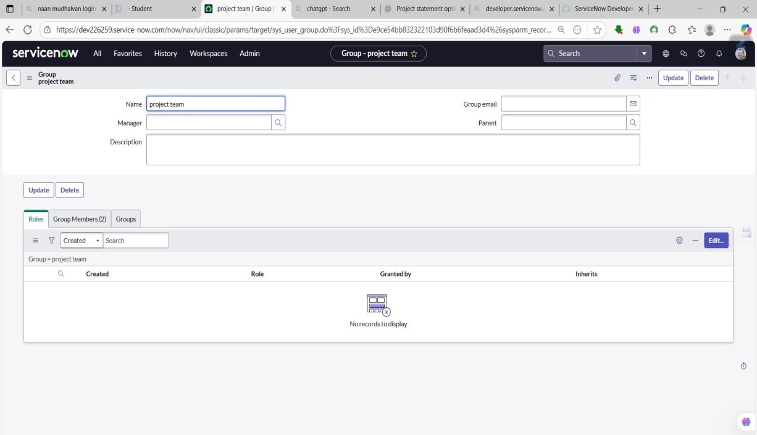

# Milestone 3 : Roles Activity1:Createroles

1. Open service now.
2. Click on All>> search for roles.
3. Select roles under system security.
4. Click on new.
5. Fill the following details to create a new role.
6. Click on submit.

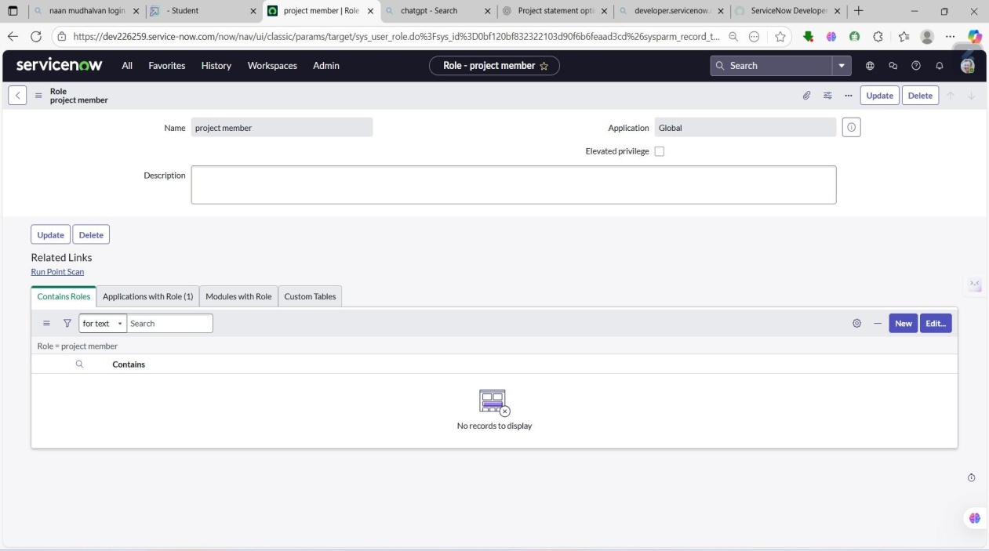

# Create one more role:

1. Create an other role with the following details.
2. Click on submit .

# Milestone 4:Table Activity 1:Create Table

1. Open service now.
2. Click on All>> search for tables.
3. Select tables under system definition.
4. Click on new.
5. Fill the following details to create a new table Label : project table.

Check the boxes Create module & Create mobile module.

1. Under new menu name: project table.
2. Under table columns give the columns.
3. Click on submit..

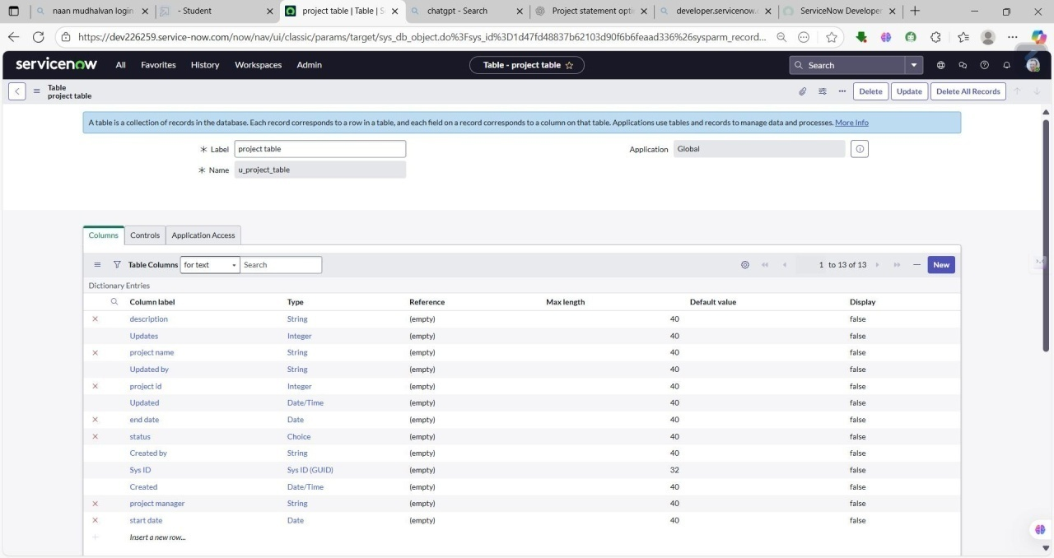

# Create one more table:

1. Create an other table as: task table 2and fill with following details.
2. Click on submit.

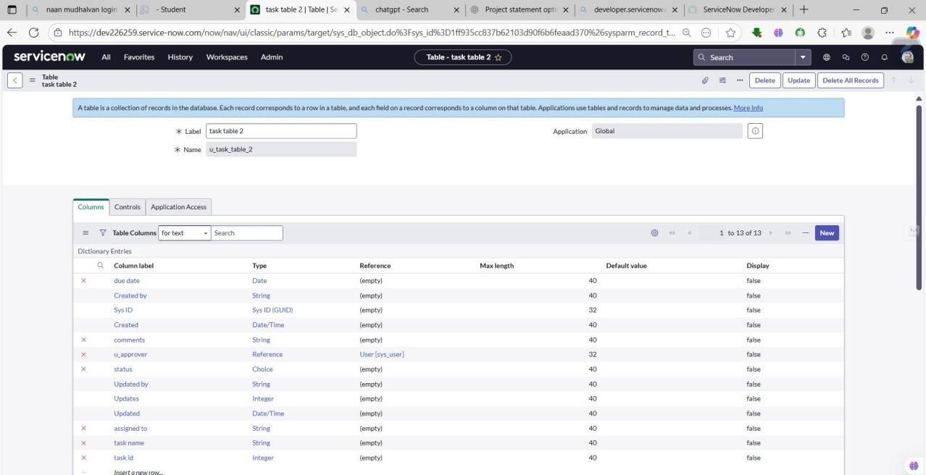

# Milestone 5 :Assign users to groups

**Activity 1:Assign users to project team group**

1. Open service now.
2. Click on All>> search for groups.
3. Select tables under system definition.
4. Select the project team group.
5. Under group members.
6. Click on edit.
7. Select Alice p and bob p and save.

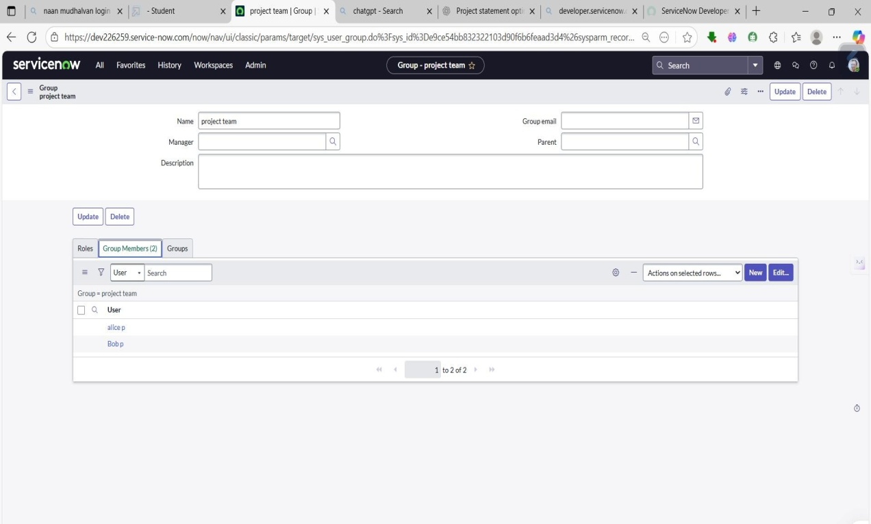

# Milestone 6 : Assign roles to users Activity1:Assign roles to Alice user

1. Open service now. Click on All>>search for user.
2. Select tables under system definition.
3. Select the project manager user.
4. Under project manager.
5. Click on edit.
6. Select project member and save.
7. Click one edit add u _ project_ table role and u_ task_ table role.
8. Click on save and update the form.

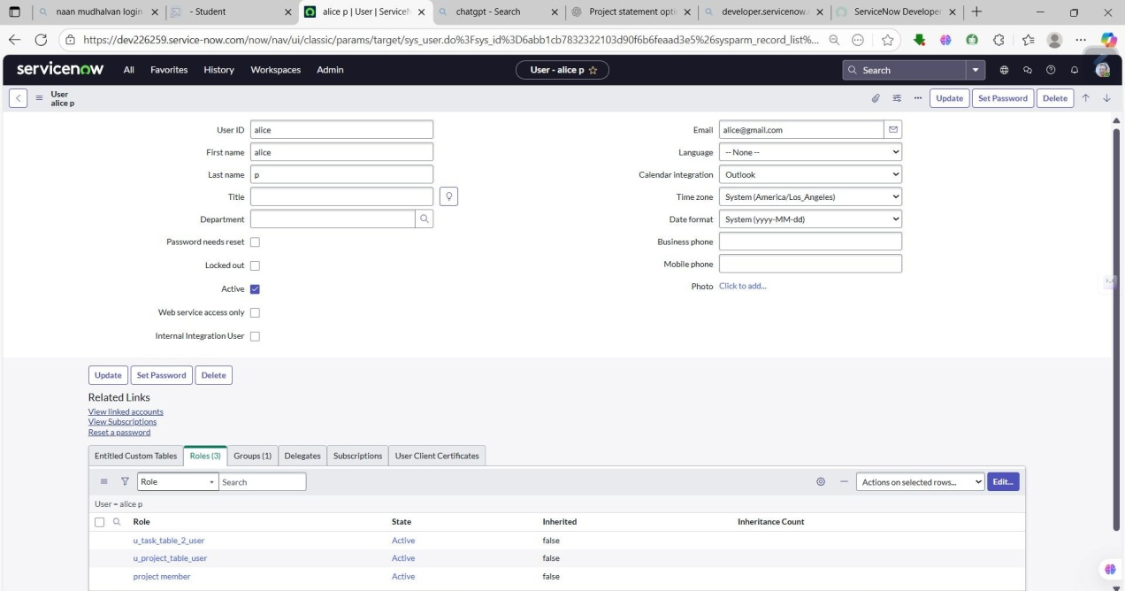

# Activity2:Assign roles to bob user

1. Open service now. Click on All>>search for user.
2. Select tables under system definition.
3. Select the bob p user.
4. Under team member.
5. Click on edit.
6. Select team member and give table role and save.
7. Click on profile icon Impersonate user to bob.
8. We can see the task table 2.

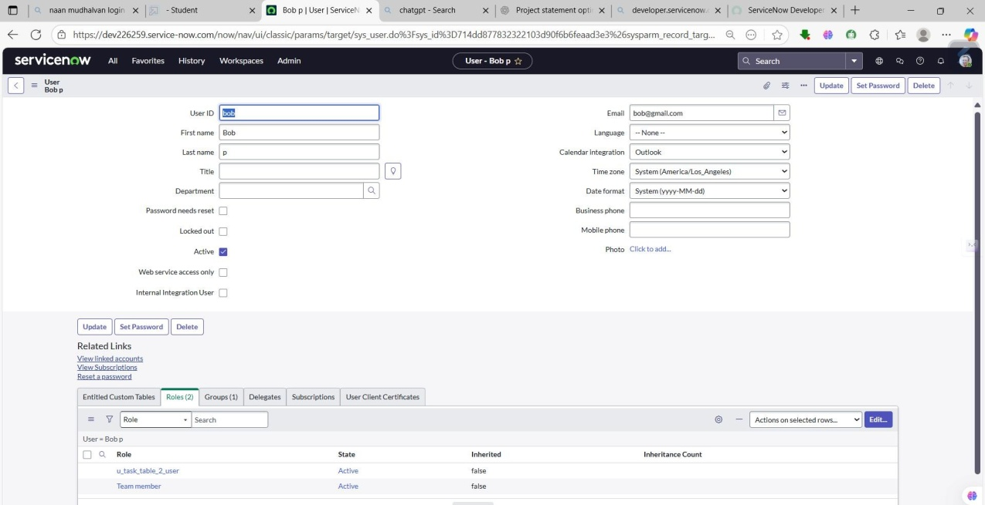

# Milestone7:Application access

**Activity1:Assign table access to application**

1. While creating a table it automatically create a application and module for that table.
2. Go to application navigate or search for search project table application.
3. Click one edit module.
4. Give project member roles to that application.

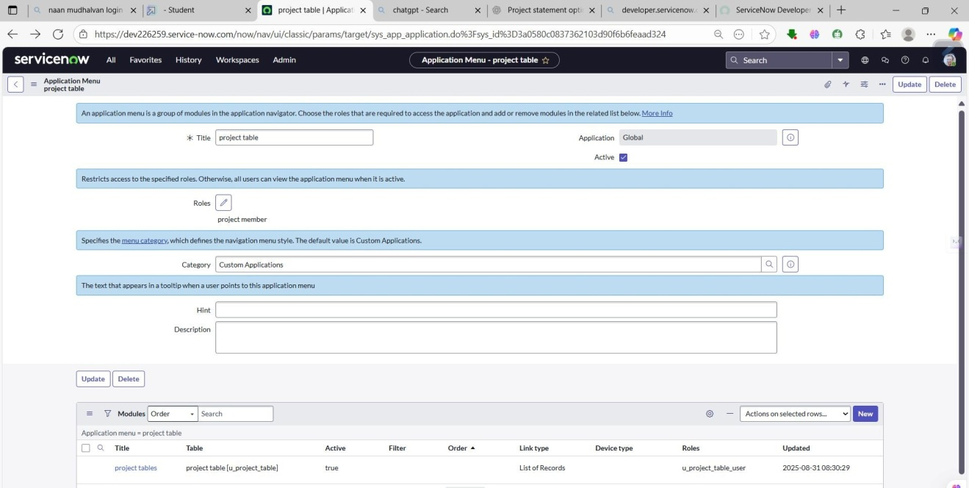

1. Search for task table 2 and click one edit application.
2. Give the project member and team member role for task table 2 application.

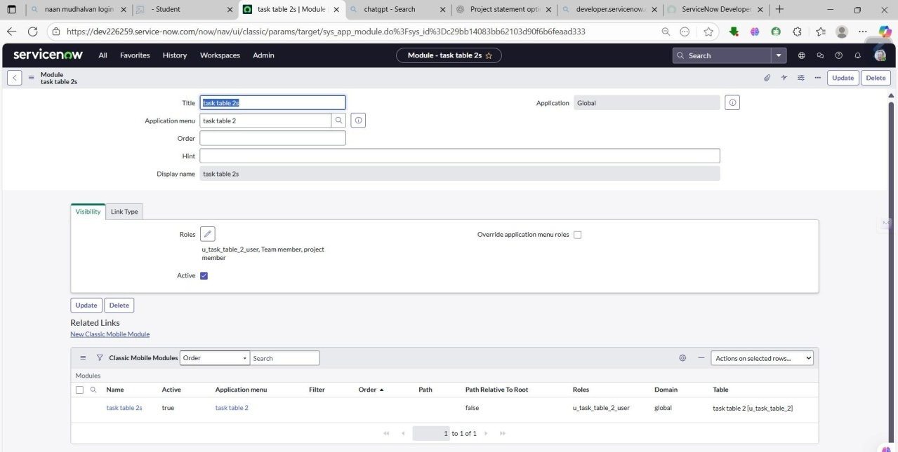

# Milestone8:Access control list Activity 1:Create ACL

1. Open servicenow.
2. Click on All>>search for ACL.
3. Select Access Control(ACL)under system security.
4. Click on elevate role .
5. Click on new.
6. Fill the following details to create a new ACL.
7. Scroll down under requires role.
8. Double click on insert a new row.
9. Give task table and team member role.
10. Click on submit.
11. Similarly create 4 acl for the following fields.

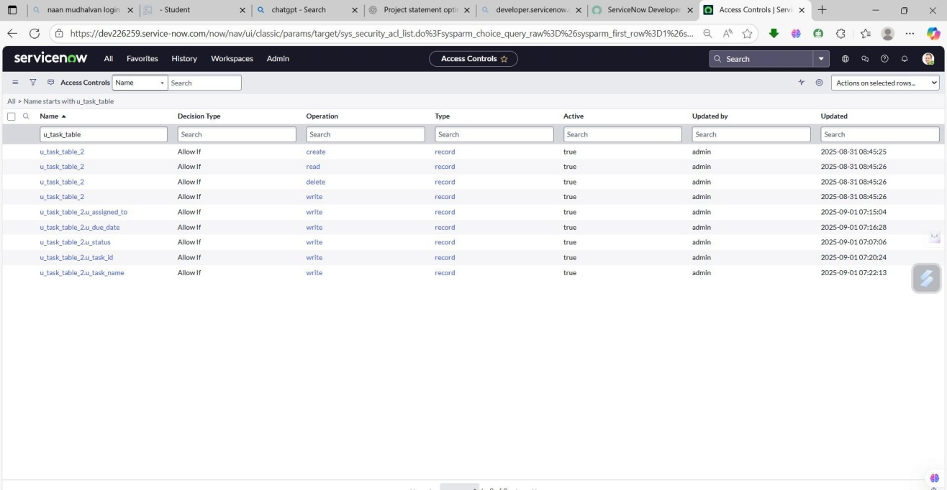

1. Click on profile on top right side.
2. Click on impersonate user.
3. Select bob user.
4. Go to all and select task table 2 in the application menu bar.
5. Comment and status fields are have the edit access.

.

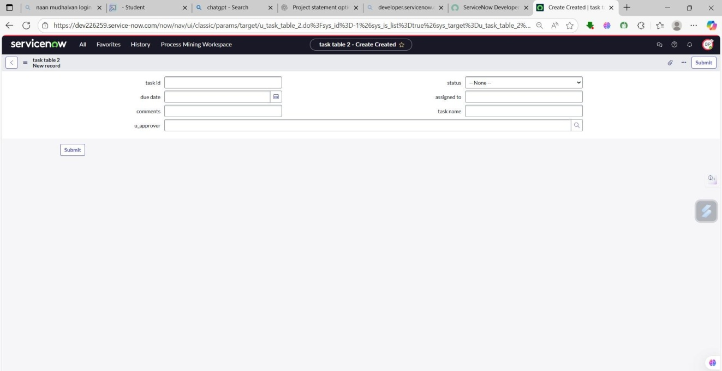

# Milestone9: Flow

**Activity1:Create a Flow to Assign operations ticket to group**

1. Open service now.
2. Click on All>> search for Flow Designer.
3. Click on Flow Designer under Process Automation.
4. After opening Flow Designer Click on new and select Flow.
5. Under Flow properties Give Flow Name as “task table”.
6. Application should be Global.
7. Click build flow.

# Next step:

1. Click on Add a trigger.
2. Select the trigger in that Search for “create record” and select that.
3. Give the table name as“ task table”.
   * Give the Condition as Field : status Operator :is Value :in progress Field : comments Operator :is Value : feedback.

Field: assigned to Operator :is Value : bob.

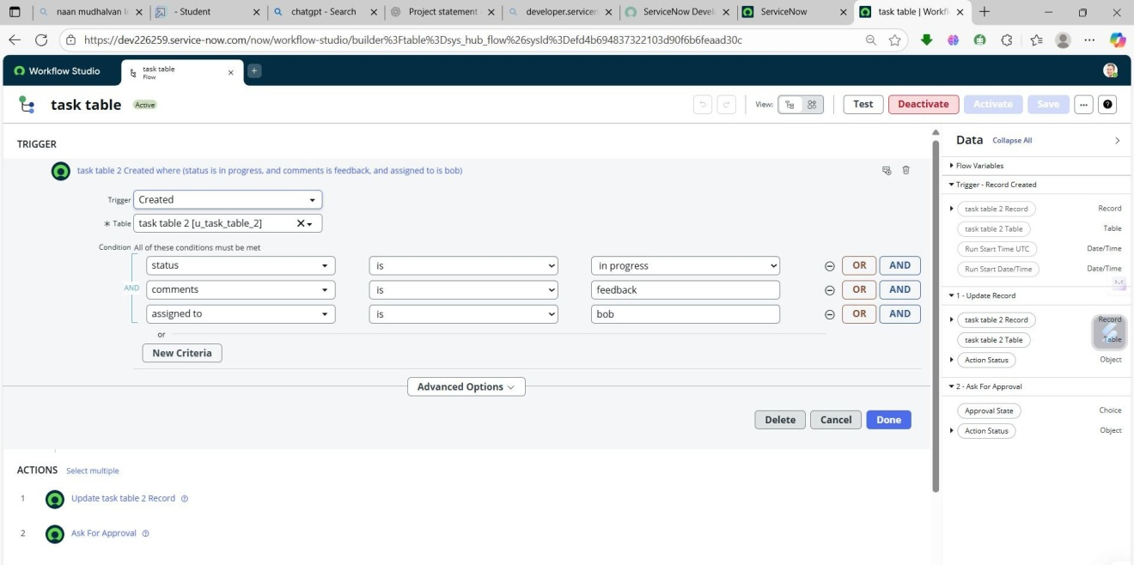

1. After that click on Done.

# Next step:

1. Click on Add an action.
2. Select action in that ,search for “update records”.
3. In Record field drag the fields from the data navigation from Right Side(Data pill).
4. Table will be auto assigned after that.
5. Add fields as “status” and value as“ completed”.
6. Click on Done.

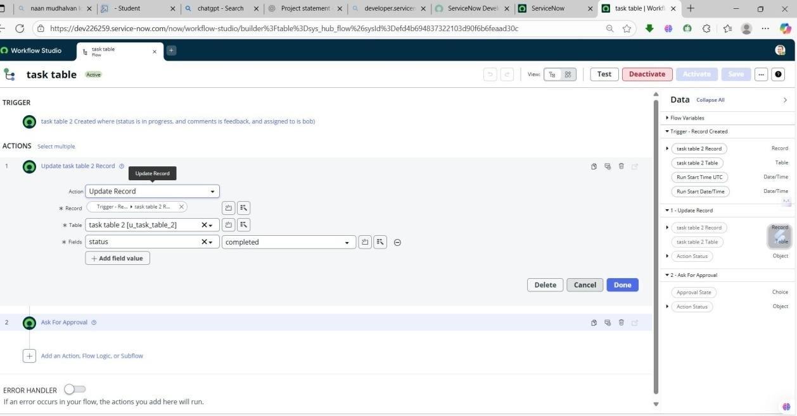

# Next step:

1. Now under Actions.
2. Click on Add an action.
3. Select action in that, search for “ask for approval”.
4. In Record field drag the fields from the data navigation from Right side.
5. Table will be auto assigned after that.
6. Give the approve field as“ status”.
7. Give approver as Alice p.
8. Click on Done.

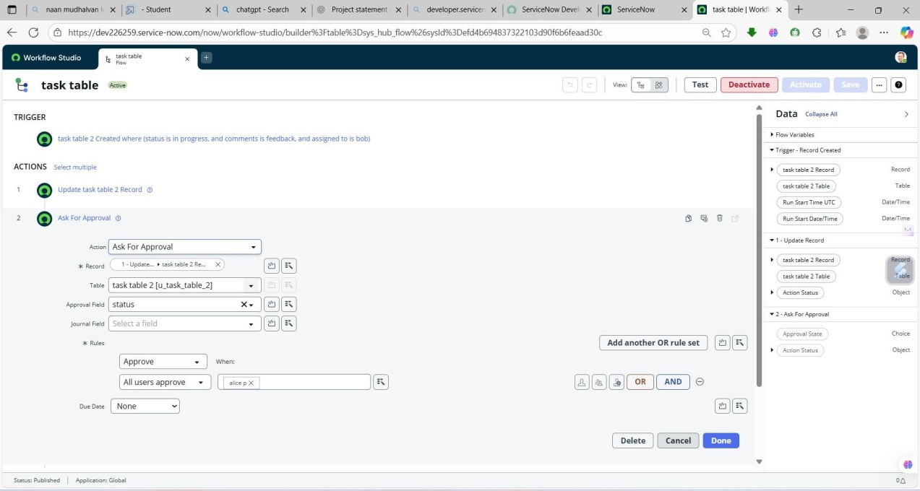

1. Go to application navigator search for task table.
2. It status field is updated to completed.

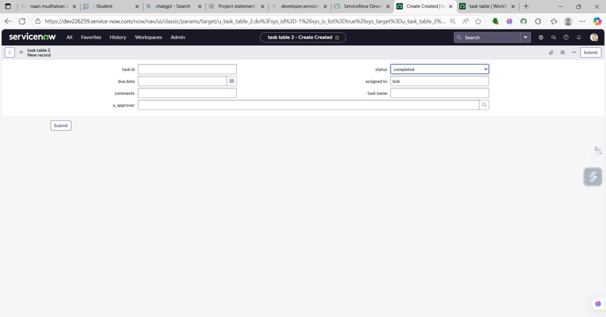

1. Go to application navigator and search for my approval.
2. Click on my approval under the service desk.
3. Alice p got approval request then right click on requested then select approved .

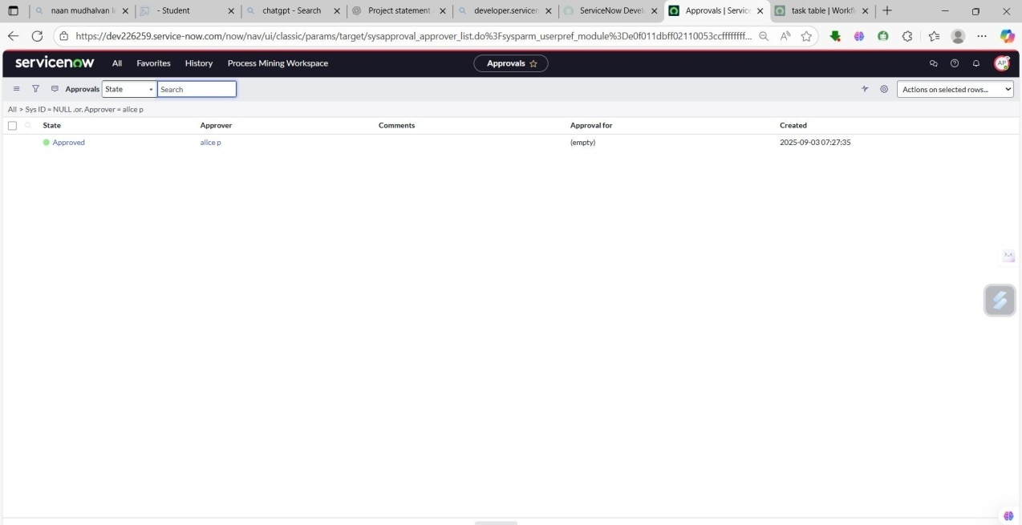

# Conclusion:

This project on **optimizing user, group, and role management with access control and workflows** has shown the importance of establishing a structured approach to identity and access management within organizations. By implementing role-based access control (RBAC), the system ensures that users receive the right access at the right time, reducing the risks of unauthorized activities and maintaining the principle of least privilege.

The introduction of **workflow automation** further enhanced efficiency by streamlining processes such as on boarding, approvals, and de-provisioning. This not only reduced manual effort but also improved accuracy and accountability, while audit trails and compliance features provided greater transparency for governance .Together ,these elements strengthened security while improving overall productivity.

In conclusion, the project demonstrates that effective user and role management is not just a technical necessity but a strategic requirement for modern organizations. By combining access control with automated workflows, organizations can achieve scalability, compliance, and operational efficiency, creating a secure and sustainable framework for managing digital identities.